Q1:R program about log return

Summary statistics

second

|  |  |  |  |  |  |  |
| --- | --- | --- | --- | --- | --- | --- |
| Mean | Median | Min | Max | Standard deviation | Skewness | Excess kurtosis |
| 7.935821e-07 | 0.000000e+00 | -8.478702e-04 | 7.827789e-04 | 1.063285e-04 | -2.660477e-01 | 6.804509e+00 |

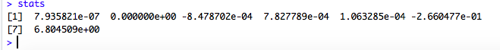

Scatter

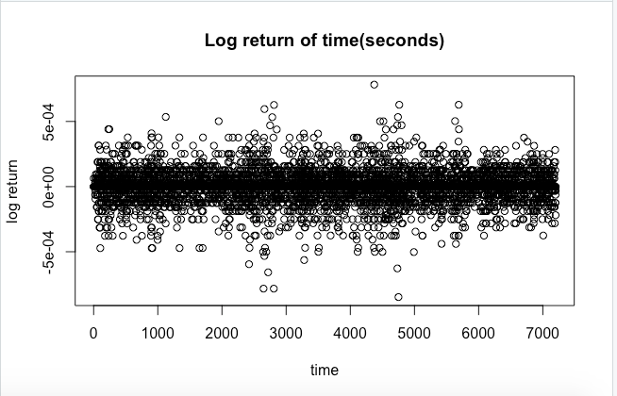

Histogram

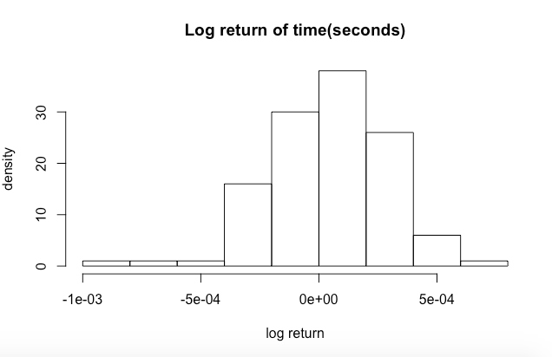

Density

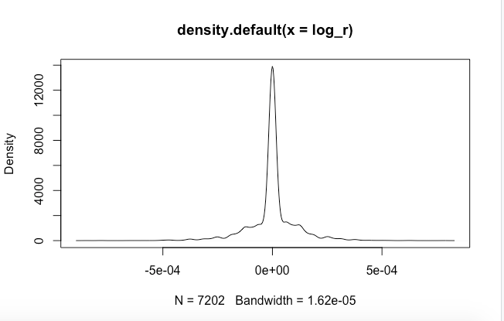

Minute

|  |  |  |  |  |  |  |
| --- | --- | --- | --- | --- | --- | --- |
| Mean | Median | Min | Max | Standard deviation | Skewness | Excess kurtosis |
| 4.897166e-05 | 6.462983e-05 | -8.059761e-04 | 7.114258e-04 | 2.486477e-04 | -3.857743e-01 | 7.412144e-01 |



scatter

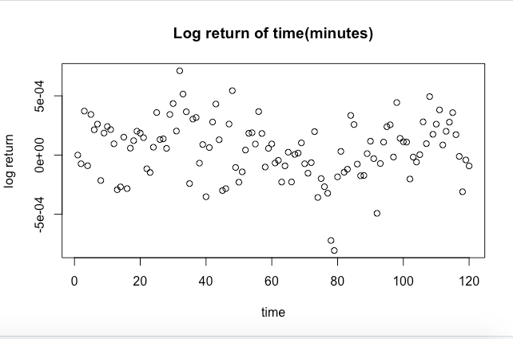

histogram

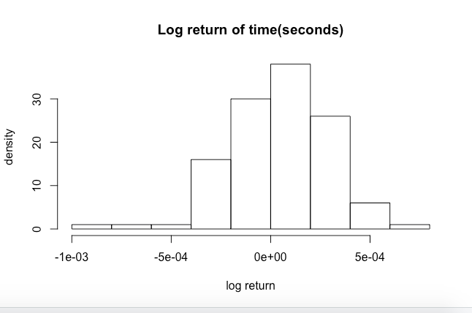

Density

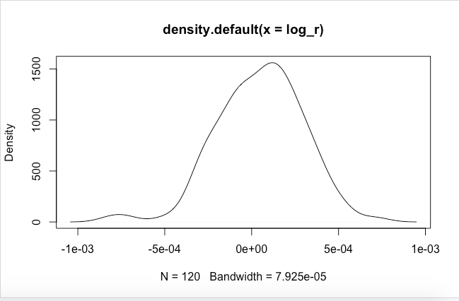

Comment:

Judging from the histogram, the distribution of log_return approaches the Standard Normal Distribution.

Q2: Cocos

1. The difference lies in the conversion conditions. The traditional convertible bonds can only be converted to equity when its stock price fall below the strike price. But the CoCos can be converted when the debt ratio of the company who issued the bonds fall below a certain value. Thus, it restrains the leverage ratio of the company to reduce the risk, which can protect the rights of bondholders. Besides, the return ratio of CoCos is relatively higher than other bonds today(according to the essay).
2. **Firstly**, according to the essay, the banks are forced to convert the bonds when their debt ratio fall below the specific level, which can help to control the risk of banks.

**Secondly**, banks will reduce their expense on dividends and interests, when the bonds convert to equity so that they don’t need to pay for the interests of the bonds or the dividends of their equity.

**Thirdly,** it helps bank to meet capital requirement.

**Fourthly**, according to the essay, “ CoCo Coupon payments are tax deductible”. It may help banks to save their expense.

Q3:Bitcoin

1. In long run, the value of Bitcoin is highly elastic to the expectation of the participants in the Bitcoin Market. Anything, such as the exhibition of Bitcoin , may cause big changes in its price.

In short run, the decentralization property of Bitcoin makes it harder to adjust its price according to the conflicts between supply and demand in its market.

1. Real assets & financial asset.

For miners, bitcoins are like a product which they product by mining.

For other investors, bitcoins aren’t a real product. It’s just the ownership of the “block candidate”.